CPSWV Teaching and Learning Model

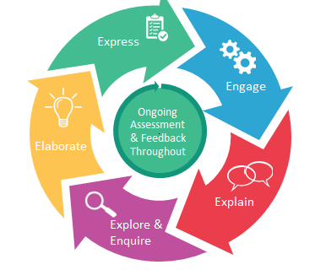
Express
Engage
Ongoing Assessment & Feedback Throughout
Elaborate
Explain
Explore & Enquire

Express

Vision for Learning

Our Vision for Learning articulates our aspirations and beliefs about teaching and learning. With pupils at its centre, the Vision outlines our aspiration for all pupils to achieve and grow as learners, and to generate their own course for
lifelong learning. Pupils will be empowered to take ownership of their learning, to make purposeful contributions to their learning environments, and to tackle issues arising in the world around them.
The Vision for Learning also recognises the central role of teachers as they use expert knowledge, skills and dispositions as designers. They develop engaging and challenging learning sequences and create the optimal conditions for
pupil learning, including supporting parents as first educators and partners in education. Teachers model lifelong learning as they build reflection and deep levels of thinking into their practice and challenge themselves and their pupils to co-construct and apply new knowledge.

Let us go back to the fundamentals of teaching and learning. Plan from the desired outcome (what do you want them to achieve?) consider the ‘golden nuggets’ of knowledge that you have identified for the unit of work you are planning, that you want to make stick. Ensure that you scaffold and challenge throughout. Assess and check understanding through a variety of retrieval practices/Proof of Progress tasks/double page spreads and effective questioning .

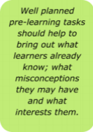

Pre-learning task: to begin the unit of work.

Teachers should take account of the outcomes from pre-learning tasks to plan the subsidiary learning challenges for each major area of study. It should help teachers recognise what transferable skills learners have already developed that could be used to initiate new learning with a level of confidence.
Pre-learning tasks ensure that learners are directly involved in the planning process. Well planned pre-learning tasks should help to bring out what learners already know; what misconceptions they may have and what really interests them.
Pre-learning tasks could take many different forms and can last for as long or as short as required. Some may be written tasks, others oral. Mind mapping is one method, which has been used successfully by many schools.

Teachers know their pupils well and engage them in building supportive, inclusive and stimulating learning environments. Teachers motivate and empower students to manage their own learning and develop autonomy. Pupils reflect on what they know, begin to make connections between prior and new learning and organise thinking towards a big question.
In designing the sequence of learning teachers and learners are using a prime learning challenge, expressed as a question, as the starting point. Using the information gained from pre- learning tasks and the school’s context, a series of subsidiary challenges are then planned into each session. Each subsidiary learning challenge is also expressed as a question. This enables the children to see how they are going to answer this question and draw on their skills and knowledge to do so. An example of this would be: Where do the leaves go in winter?

Engage
All children should have exposure to authentic resources which inspire them to create beautiful work. All children should be exposed to high challenge, low threat tasks.
Real learning takes place when we make mistakes, take risks, and think metacognitively. It is important that things aren’t too easy because this risks not learning anything significant or placing it in long term memory. We do not differentiate groups or limit learning in any way but take a mastery approach to all curriculum areas. We ensure children are able to reflect on what they know, begin to make connections between prior and new learning and organise thinking towards a big question.

Explain
Teachers explicitly introduce and teach relevant knowledge, concepts and skills in multiple ways to connect new and existing knowledge. They challenge misconceptions and prepare pupils to navigate their own learning. Pupils know what excellence looks like and how to achieve it, as well as mistakes to avoid.
Success Criteria
In order for children to fully understand your expectations, constructing and co-constructing success criteria helps to cement the process they need to go through to achieve well. It can also act as a tool to enable discussion about learning, peer to peer and learner to teacher.
If we use a cake recipe analogy, we have our procedures for adding the ingredients to the mixing bowl, but if we neglect to follow them, we might end up with a disaster. The same is true for our lessons.
Using dual coding within success criteria can be a useful tool to support learners to remember more. It is often most useful when children co-construct this with you. You do some shared writing with them based on this, model editing and revising skills as part of the writing process.

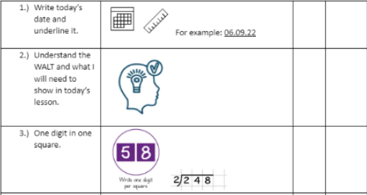

Knowledge Organisers
These are developed at the beginning of the learning journey and shared with the children, they are referred to throughout the learning journey and can be used for retrieval practice. They must include the key knowledge in which children are expected to become secure. See an example below:
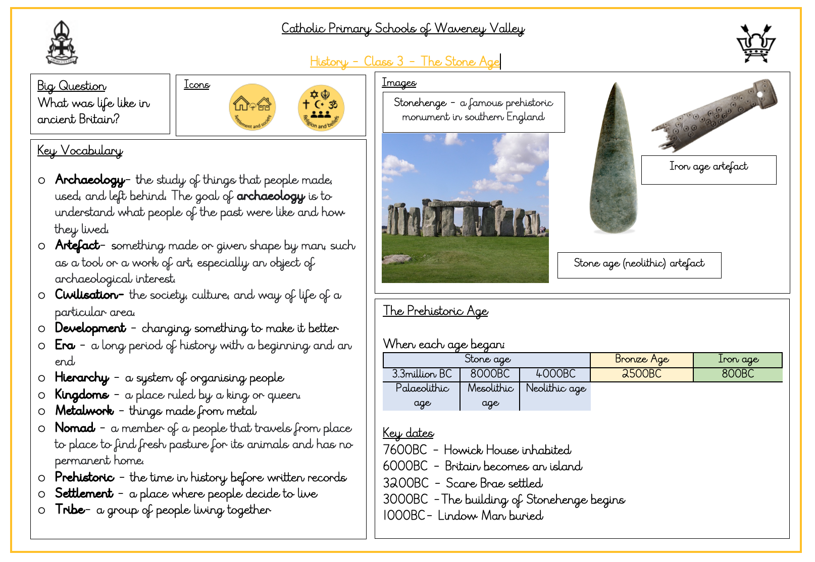

A knowledge organiser is a document, usually no more than two sides of A4, that contains key facts and information that children need to have a basic knowledge and understanding of a topic.
Most knowledge organisers will include:
● the essential facts about the topic, usually laid out in easily digestible chunks
● key vocabulary or technical terms and their meanings
● images such as maps or diagrams
● famous quotations, if relevant.

What a knowledge organiser includes will depend on the subject. For example, a ‘Second World War’ knowledge organiser and a ‘Rivers’ knowledge organiser would both include maps, but the former would also include a timeline, and the latter would need diagrams.
How can we use them in the classroom?
Give the knowledge organiser to the children before the start of a topic to encourage discussion and prior research. You must also send a copy home. This will support the parents in understanding more about what their child is learning.
Talk through the knowledge organiser at the beginning of the topic, asking the children what information has sparked their interest, and if they have any questions.
Use the knowledge organiser as a regular retrieval tool. Mix up practice using short, low stakes quizzes, games, partner discussion, and so on, rather than constant formal testing. Do the children know more than is included on the knowledge organiser? Ask higher-level ‘why’ questions to stretch the children’s understanding and add detail. This is the ideal scenario, as it means they have deepened their knowledge beyond the baseline outlined on the knowledge organiser and have formed stronger schemata.
Use the knowledge organiser to identify knowledge gaps throughout the topic.
Display an enlarged copy of the knowledge organiser on a working wall, encouraging children to add information around it during the topic.
Use knowledge organisers to strengthen teacher knowledge in a subject area.
Glue the knowledge organisers into the children’s topic books for regular reference or cut up the sections to focus the children and deepen their knowledge in a particular area.
Make links between knowledge organisers to help children understand how their learning connects. For example, remind the children of a previous year’s knowledge organiser and discuss how their new knowledge links and builds upon it.
Use the knowledge organiser as a handy spelling and vocabulary reminder. Keep it visible at all times and expect the children to use the proper vocabulary correctly.
Use the knowledge organisers as guided reading texts. This way, you can help children read the information and check they understand it. It is an essential tool for teaching high-tiered vocabulary.

Explore

Teachers facilitate and monitor pupil progress in learning and provide multiple, structured opportunities for practising new skills and developing fluency. Pupils build on prior knowledge and explore and investigate objects, events and situations. Pupils construct or revise their own explanations and mental models
The teacher uses retrieval and spaced practice to build automatic recall of essential knowledge and ideas
• Provides time and multiple opportunities for pupils to practise, embed and reinforce new learning until learning is fluent and secure
• Adapts learning, providing support, prompts and scaffolding (guided practice) through the initial stages of practice, including breaking tasks down into smaller constituent components; or providing additional stretch through questions to extend thinking
• Gives pupils opportunities to interact with and support each other in learning
• Uses flexible grouping to support pupils to fill knowledge gaps or deal with misconceptions
• Regularly monitors pupils’ understanding and adapts instruction to meet pupils’ needs
• Uses a range of questioning techniques to engage pupils, stimulate further investigation and redirect pupils when necessary
• Promotes pupils' independence and prepares them to undertake self-directed inquiry
• Gradually removes support as pupils’ expertise increases (e.g. ‘I do-We do-You do’ model – from guided to independent practice)

Elaborate
Teachers challenge pupils to move from surface to deep learning, building their ability to transfer and generalise their learning. They support pupils to be reflective, questioning and self-monitoring learners. Pupils apply, extend or elaborate (stretch) their knowledge and skills through problem solving, designing experiments, etc.
The teacher (once pupils have mastered essential knowledge and skills)
- praises pupils for attempting or persevering with challenging work or exceeding expectations
- demonstrates what to do when facing challenging content and how effort leads to learning success
- facilitates learning activities that challenges and deepens knowledge and understanding, including: activities involving discipline-rich inquiry, problem solving, collaboration and pupil choice
- models and develops pupils’ critical, creative and higher order thinking skills
- supports pupils to form theories, find patterns and make connections in their learning
- challenges pupils to demonstrate their learning in a variety of ways
- encourages pupils to share their learning and challenge each other
- Uses questioning to probe student thinking and prompt them to justify their responses; getting responses from all pupils
- provides pupils with targeted feedback that challenges them to reflect on and refine their understanding at various points in a learning sequence

Express

Teachers design a range of purposeful tasks/opportunities that enable pupils to express and demonstrate their knowledge and understanding of the outcome or big question at the end of a sequence of work or topic. Pupils express the knowledge and understanding they have gained to answer the big question, demonstrating that they know and remember more.

The teacher:
- begins with the end in mind, designing a sequence of learning towards a big question of learning outcome tasks
- designs a range of purposeful opportunities or tasks that will enable pupils to answer the big question or express and demonstrate what they know, can do and can remember (Express / Proof of Progress (POP) tasks/double page spreads)
- sets clear learning intentions and success criteria to ensure there is a shared understanding of excellence
- analyses pupil’s performance in tasks to identify gaps in learning
- adjusts and adapts the way they plan or teach units of work in the future, based on analysis of POP tasks
- supports future learning by providing feedback to pupils on their progress against learning goals, success criteria and curriculum standards
- supports pupils to monitor their own learning through structured reflection and self-assessment, including identifying next steps and goals
- challenges pupils to make their learning explicit and demonstrate what they know and can do in variety if ways
- uses assessment to establish starting points for next steps and plan backwards, planning structured lessons and coherent sequences of learning relevant to pupils’ needs and abilities

Evaluate
Teachers use multiple forms of assessment and feedback to help students improve their learning and develop fluency. They monitor pupil progress and analyse data to draw conclusions about the effectiveness of their teaching practices, identify areas for improvement, and address pupils’ learning needs. Pupils are encouraged to evaluate and assess their own progress and understanding and provide evidence of their learning in different ways.
How do you know if they “got it?” Did you ask important closing questions? Did you do a quick assessment as students leave the room? You can use all kinds of varied activities to check for understanding that don’t include formal test taking. The use of double page spreads for example, are an excellent way to collate all the knowledge from a unit of work.
Feedback is an important process in the lesson cycle because it allows children to know how they are progressing, edit, improve, and enter into constructive dialogue with their peers and teacher. Feedback can take place as a whole class, group, one to one and at any and all points in the lesson. The more immediate the better! Use misconceptions collated as a tool for teaching the next lesson. The use of whole class feedback will really inform your next steps and asking the children to inform you of what they think you should focus on and what they have struggled with is a powerful tool.
Using a visualiser is a good tool to facilitate this process. Retrieval practices such as quizzes, brain dumps, exit tickets and challenge grids are a useful way to assess children’s learning.

Live marking – pink for think, green for good
Encourage children to talk about their learning by reflecting on what they did, how do they know they are successful? Give them other chances to prove it by posing skills in different ways. It is an immediate way of sharing with children their next steps and for them to be involved in this process.
For example – let’s use our diary writing steps to success to write a diary as though we were Florence Nightingale. Remember the skills you used and apply them.

Learning walls are both a tool for teaching and for children to access to aid their learning. Learning Walls
● Maths reasoning sentence stems
● WAGOLLS - use carefully with small step instructions to sequence the learning to achieve the overall outcome
● Success Criteria- dual coded when appropriate
● Key Vocab
● Thinking prompts
● Worked examples - anchor charts
● Planning stages
● Editing stations
● Children’s work that is a good example to others

Books
Standards in books should demonstrate high expectations from teachers and pupils alike. Children’s hearts should be connected to their learning through an aspiration for beautiful work. We expect to see the following:
● Long date – written work - underlined
● Short date – maths work - underlined
● Title underlined
● Age and developmentally appropriate presentation of handwriting and work
● Any sheets should be minimal but if used cut to fit books and carefully stuck in neatly
● Topic books – scrapbook style with coloured paper to represent each curriculum area
● double page spreads that allow children artistic licence to showcase the knowledge learned

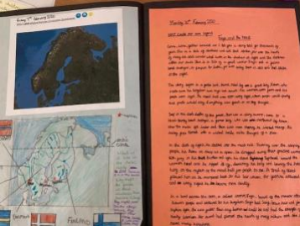

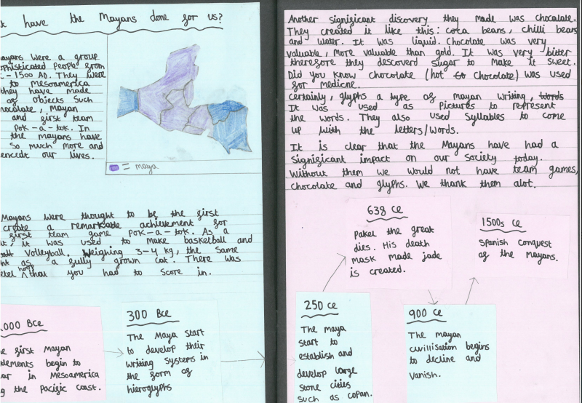

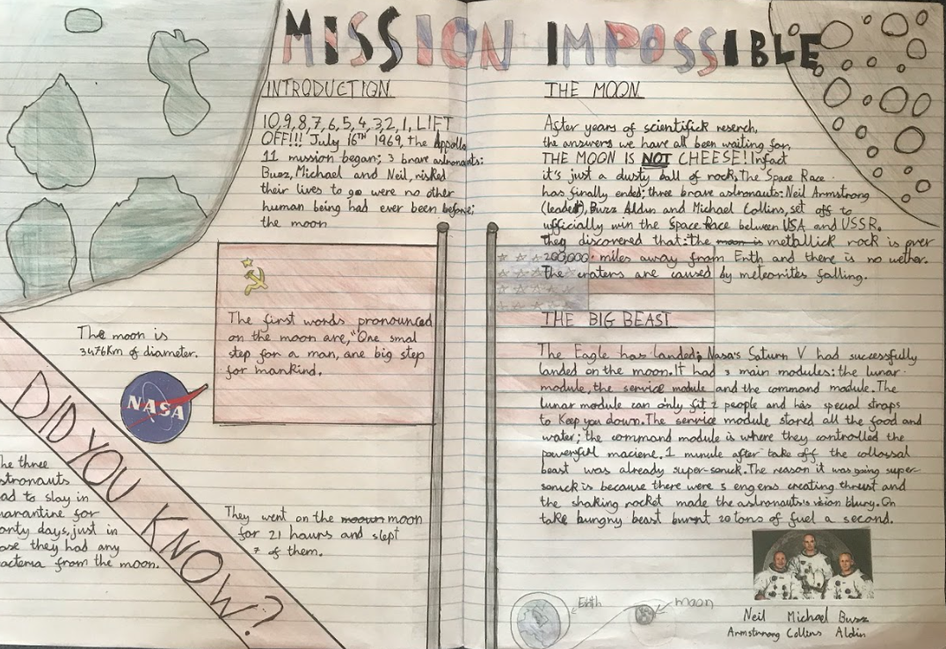

HITS (High Impact Teaching Strategies)

What are High Impact Teaching Strategies?
The High Impact Teaching Strategies (HITS) are nine evidence-informed instructional practices that reliably improve pupils’ learning. The HITS will not be new to most teachers. On their own the HITS are not a complete framework for professional practice – they are part of a set of instructional practices which together provide a comprehensive school and MAT Teaching and Learning Model.
Using HITS to teach a concept or skill that pupils need to learn will increase the chances that they will successfully learn it, compared to using other strategies. However, although these practices are reliable, they are not infallible. Knowing their pupils and how they learn, teachers are best-placed to judge whether a HITS or another strategy is the best choice to teach that concept or skill.
• Setting Goals - Effective teachers set and communicate clear lesson goals to help pupils understand the success criteria, commit to the learning, and provide the appropriate mix of success and challenge.
• Structuring and Scaffolding Lessons– Effective teachers plan and deliver structured lessons which incorporate a series of clear steps and transitions between them, scaffolding learning to build students’ knowledge and skills. They support learning by facilitating rather than directing, fostering goal setting and collaboration to develop pupils’ autonomy.
• Explicit Teaching (Direct Instruction) - Effective teachers use explicit teaching to provide instruction, demonstrate concepts and build pupils’ knowledge and skills. In explicit teaching practice, teachers show pupils what to do and how to do it, and create opportunities in lessons for pupils to demonstrate understanding and apply the learning.
• Modelling and Worked Examples- Effective teachers use worked examples to reduce pupil cognitive load, enabling them to focus on understanding a process which leads to an answer, not the answer itself.
• Retrieval Practice – Research has demonstrated time and again that retrieval practice, or reconstructing knowledge by bringing it to mind from your memory, has been shown to improve meaningful learning. (see Roediger et al., 2011) Low stake quizzes, POP TASK, multiple choice tests etc
• Spaced Practice - It takes ‘three or four experiences involving interaction with relevant information for a new knowledge construct to be created in working memory and then transferred to long-term memory’ (Nuthall, 2000, p.93). Spaced practice provides pupils with multiple opportunities to encounter, engage with, and elaborate on new knowledge and skills. It is not simple repetition or drill work. Research demonstrates that deep learning is developed over time via multiple and spaced interactions with new knowledge and concepts.
• Questioning - Effective teachers regularly use questioning as an interactive means to engage and challenge pupils, and use it as a tool to check pupil understanding and evaluate the effectiveness of their teaching.
• Feedback - Effective teachers use two-way feedback to gather information about a pupils’ understanding, to assist pupils to advance their own learning, and to verify the impact of their own practice. Feedback informs a pupil and/or teacher about the pupil’s performance relative to learning goals. Its purpose is to improve the pupil’s learning. Feedback redirects or refocuses the actions of teacher and pupil so the pupil can align effort and activity with a clear outcome that leads to achieving a learning goal. (See Feedback and Marking Policy)
• Adaptive Teaching - Responsive teachers ‘check learners understanding systematically, identify misconceptions accurately and provide clear direct feedback. In doing so, they respond and adapt their teaching as necessary, without unnecessarily elaborate or differentiated approaches.’ Ofsted EIF 2019
• Metacognitive Strategies - Effective teachers use metacognitive strategies to help pupils develop awareness of their own learning, to self-regulate, and to drive and sustain their motivation to learn. Metacognitive strategies empower pupils to think about their own thinking more explicitly. Awareness of the learning process enhances control over their own learning.
• Reading widely throughout the curriculum, this is vital for introducing new concepts and vocabulary. The use of high quality texts enables subject specific vocabulary development and for children to have something to hand their new knowledge onto.

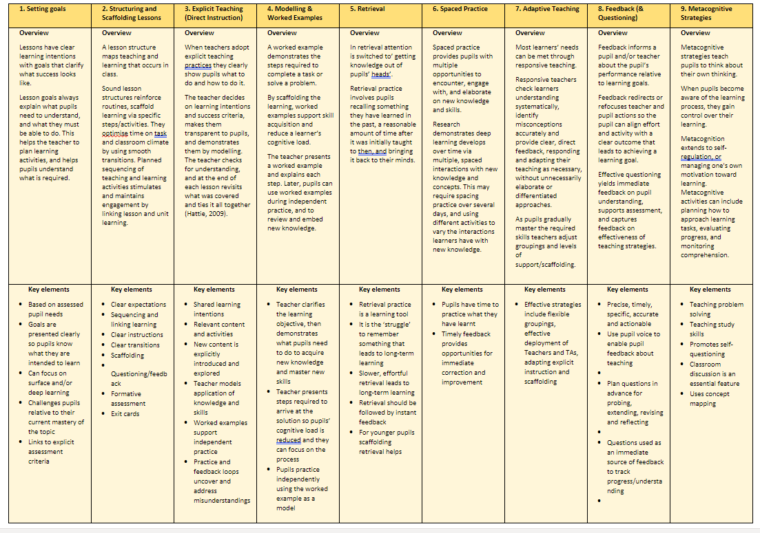
The Classroom Environment
The classroom environment should be organised and inviting. We take a Hygge approach to all classroom environments. Each classroom should reflect the learning atmosphere and expectations of a class. Anything in your learning environment that takes away the attention from the subject material is hindering learning.
Where resources are used frequently, they should be stored so that they are easy to access labelled, where appropriate. The room should be clutter free, easy to navigate and equipment and resources should be kept in good order. All children must be encouraged to look after and contribute towards the management of their own rooms, ensuring that they are in a good enough order to begin learning each session. Resources should be easy for adults and children to locate and access.
Displays and learning walls should be purposeful and well presented. Key vocab should be bold, and large enough to see anywhere in the room, images might be captioned. Displays of work might have interactive questions, children’s quotes and/or make reference to enquiry questions posed during the learning journey. Handwritten additions to displays and learning walls should be in the CPSWV joined handwriting font – modelling accurate and consistent handwriting. Minimal use of laminated or printed out headings.
Handwritten additions should be large and bold enough to be seen for the purpose which they have been designed for.
Every classroom should have an inviting and well organised reading area. They should be in good condition and age appropriate. Children must be encouraged to look after books and treat them carefully. Books should be clearly displayed and accessible. Books to reflect topics or specific subjects should be displayed, alongside any displays or work, to foster engagement and to provoke interest. The value and importance of books should be reflected in the environment.
In order to emphasise that the classroom environment is one to be treated with respect, any tabletop visual prompts or mats should be refreshed as they get worn and tattered.
In order for teaching and learning to be focused, reduce the ‘noise’ around the whiteboard areas and minimise the content of presentations to avoid cognitive overload. Simplicity – less is more.

Use STAR to support focus – S = Stop, sit up, silence, T = track the teacher, A = ask and answer questions in full sentences, R = respect those around you.
● Condensing the Powerpoint of too much text, use of more visual representations
● Less is more -reduce the amount of text/ diagrams to as little as is necessary.
● Ensure that labels are integrated into diagrams -so students can look at both simultaneously. ● Remove distracting and superfluous images -only use those that directly support learning.
● Use images to support complex and conceptual ideas -dual coding theory
● If you intend to explain an image, it's best not to include written text at the same time. ● Try not to be over reliant on your PowerPoint!

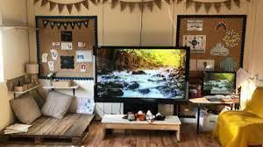
A Hygge Classroom – A place of calm and purpose. Low lighting and lamps, neutral tone boards, plants, fairy lights, hand written signs on black card and calm areas/book nooks.

