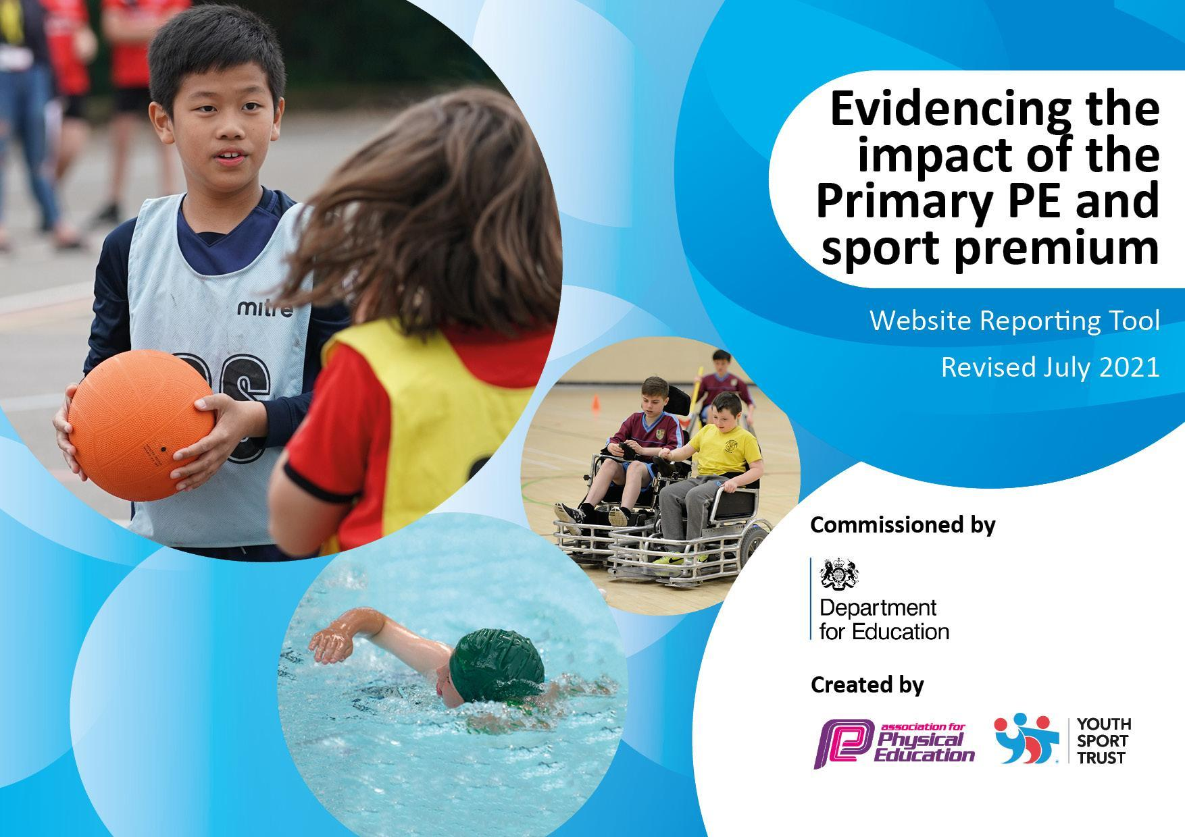
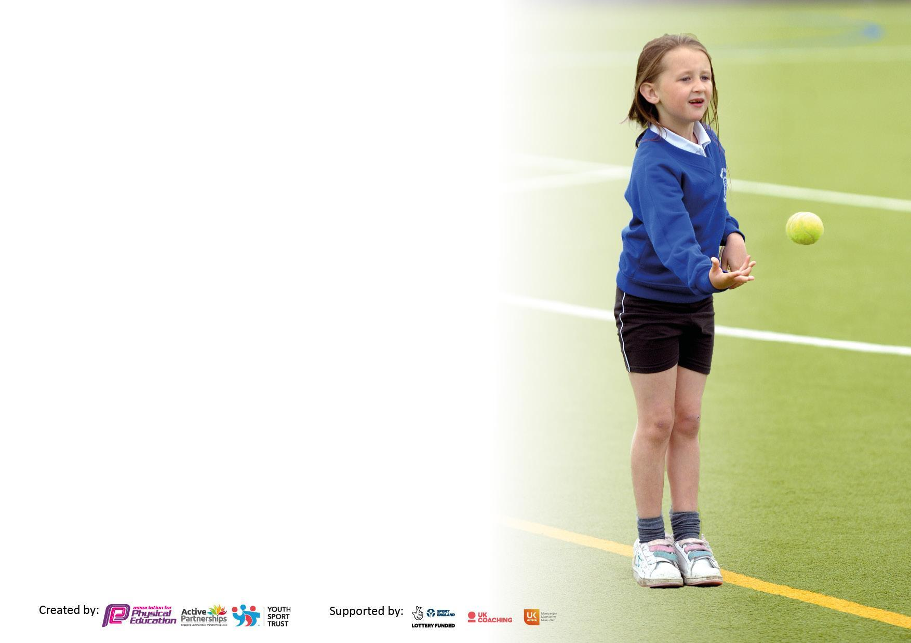

It is important that your grant is used effectively and based on school need. The Education Inspection Framework makes clear there will be a focus on ‘whether leaders and those responsible for governors all understand their respective roles and perform these in a way that enhances the effectiveness of the school’.

Under the Quality of Education Ofsted inspectors consider:
Intent - Curriculum design, coverage and appropriateness
Implementation - Curriculum delivery, Teaching (pedagogy) and Assessment
Impact - Attainment and progress

To assist schools with common transferable language this template has been developed to utilise the same three headings which should make your plans easily transferable between working documents.

Schools must use the funding to make additional and sustainable improvements to the quality of Physical Education, School Sport and Physical Activity (PESSPA) they offer. This means that you should use the Primary PE and sport premium to:

- Develop or add to the PESSPA activities that your school already offer
- Build capacity and capability within the school to ensure that improvements made now will benefit pupils joining the school in future years
- The Primary PE and sport premium should not be used to fund capital spend projects; the school’s budget should fund these.

Pleasevisitgov.ukfortherevisedDfEguidanceincludingthe5keyindicatorsacrosswhichschoolsshoulddemonstrate animprovement.Thisdocumentwillhelpyoutoreviewyourprovisionandtoreportyourspend.DfEencouragesschools to use this template as an effective way of meeting the reporting requirements of the Primary PE and sport premium.

We recommend you start by reflecting on the impact of current provision and reviewing the previous spend.

Schools are required to publish details of how they spend this funding, including any under-spend from 2019/2020, as well as on the impact it has on pupils’ PE and sport participation and attainment. All funding must be spent by 31st July 2022.

We recommend regularly updating the table and publishing it on your website throughout the year. This evidences your ongoing self-evaluation of how you are using the funding to secure maximum, sustainable impact. Final copy must be posted on your website by the end of the academic year and no later than the 31st July 2021. To see an example of how to complete the table please click HERE.

Swimming Data
Please report on your Swimming Data below.

Meeting national curriculum requirements for swimming and water safety.

N.B. Complete this section to your best ability. For example you might have practised safe self-rescue techniques on dry land which you can then transfer to the pool when school swimming restarts.
Due to exceptional circumstances priority should be given to ensuring that pupils can perform safe self rescue even if they do not fully meet the first two requirements of the NC programme of study
What percentage of your current Year 6 cohort swim competently, confidently and proficiently over a distance of at least 25 metres? | 64%
What percentage of your current Year 6 cohort use a range of strokes effectively [for example, front crawl, backstroke and breaststroke]? | 64%
What percentage of your current Year 6 cohort perform safe self-rescue in different water-based situations? | 64%
Schools can choose to use the Primary PE and sport premium to provide additional provision for swimming but this must be for activity over and above the national curriculum requirements. Have you used it in this way? | No

Action Plan and Budget Tracking
Capture your intended annual spend against the 5 key indicators. Clarify the success criteria and evidence of impact that you intend to measure to evaluate for pupils today and for the future.

Academic Year: 2022/23 | Total fund allocated:£16,650 | Date Updated:15.7.23
Key indicator 1: The engagement of all pupils in regular physical activity – Chief Medical Officers guidelines recommend that primary school pupils undertake at least 30 minutes of physical activity a day in school |  |  |  | Percentage of total allocation:
 |  |  |  | 13%
Intent | Implementation |  | Impact
Your school focus should be clear what you want the pupils to know and be able to do and about  what they need to learn and to  consolidate through practice: | Make sure your actions to achieve are linked to your intentions: | Funding allocated: | Evidence of impact: what do pupils now know and what can they now do? What has changed?: | Sustainability and suggested next steps:
To promote activity in Key Stage 2.  To monitor daily percentage of activity and when the activity is taking place.  To encourage pupils to be more active throughout their school day and reach their 60 active minutes. | Ensure KS2 classes have working moki bands and batteries throughout the year | £77 | Pupils are really keen to use the Moki bands each day. They are more active and look forward to seeing how many steps they have completed each day. We can monitor our activity and periods of the day when we have been more or less active. Teachers are more aware of when the children need to become more active throughout the day. | There is the opportunity to complete house weekly leaderboards. We can have weekly leaderboards and targets.
Continue to promote the Daily Mile in every class. | Ensure every class is completing the Daily Mile. | Free | Children from every class complete the Daily Mile each day providing them with a further opportunity to increase their daily activity and support their mental wellbeing. | To continue with Daily Mile in 2023/2024 to promote activity. Teachers have the flexibility to complete this at the best time of the day for their class.
Sports Day - This will be divided into two separate sessions. | In July, we held a sports day, where KS2 took part in races in the afternoon and KS1 and Reception had theirs in the morning. | Free | Emphasis was on participation , all pupils were given the opportunity to run every race. | Revise for next year where appropriate. It was a very successful day.
Ensure school is fully resourced ready for lessons. Order resources for play leaders to use with the younger children.  Each class to have their own set of resources to access at lunchtimes and break times | Equipment ordered for lessons and break times. | £2165.57 | Pupils are now more active at lunchtimes and break times as they are playing with the equipment offered. | Year 5 pupils to take over as play leaders for the younger children in the school next year. Equal opportunities for girls and boys.
Key indicator 2: The profile of PESSPA being raised across the school as a tool for whole school improvement |  |  |  | Percentage of total allocation:
 |  |  |  | 0%
Intent | Implementation |  | Impact
Your school focus should be clear what you want the pupils to know and be able to do and about  what they need to learn and to  consolidate through practice: | Make sure your actions to achieve are linked to your intentions: | Funding allocated: | Evidence of impact: what do pupils now know and what can they now do? What has changed?: | Sustainability and suggested next steps:
Pupils will learn maths and english skills in an active way using tag belts. | Use Maths and English Tagtiv8 belts effectively | Belts have already been bought. | Belts are being used in small groups to practise and learn the times tables. | Subject to consider formal training opportunities and to expand resources across classes where required.
Sports Leaders and play leaders to promote activity around the school and develop good leadership skills. | Class 4 pupils lead certain events and run groups every lunch time for the younger pupils. | Free | Year 6 pupils are running groups effectively at lunchtimes, leading to increased activity, and improved behaviour management on the field. | To consider using the Real Leaders training resources and decide which sports we will offer next year. Current play leaders to train new Year 5 pupils ready for next year.
Use the holistic Real PE cogs to allow children to develop skills which will help them across lessons. | Ensure cogs are clearly referred to and discussed whenever they are used. Teachers to explain how they relate to their development as a whole in their life at school. | Free | Pupils will have an awareness of each cog and why it’s important for their development as a person. | To potentially display the cogs in the classroom and refer to them in different lessons.

Key indicator 3: Increased confidence, knowledge and skills of all staff in teaching PE and sport |  |  |  | Percentage of total allocation:
 |  |  |  | 2%
Intent | Implementation |  | Impact
Your school focus should be clear | Make sure your actions to | Funding | Evidence of impact: what do | Sustainability and suggested
what you want the pupils to know | achieve are linked to your | allocated: | pupils now know and what | next steps:
and be able to do and about | intentions: |  | can they now do? What has
what they need to learn and to |  |  | changed?:
consolidate through practice:
To continue to use our Real PE Project coordinator where appropriate to: train new staff, support the subject leader and provide demonstration lessons for all to learn from. | Membership of the Real PE Legacy Programme | Paid for last year. | New and less experienced teachers are more confident to teach the REAL PE programme. | To continue to train new staff effectively and provide ongoing subject leader support where required.
Get Set 4 PE resources to ensure the staff have full planning for all units to be taught. | Complete subscription for this year. | £220 | All teachers will have accurate, clear, up to date planning for all lessons. | Ensure all new teachers have access and know how to use the resources.
Subject leader to have access to the latest PE updates and recommendations. | Purchase Professional Membership to Afpe | £47.50 | Subject lead has access to the latest advice and recommendations from a professional body. | Continue with this membership next year.
Apply for school to be part of the Chance to Shine Programme, which will provide cricket lessons and CPD for all classes. | The school was registered and accepted. Each class receives 6 sessions with a trained coach across the summer term focusing on a different element of the game. | Free | Each class received lessons with a specialist coach. Enthusiasm has improved throughout the school for cricket. Our female coach was a great role model for the girls. Our teachers are more confident in delivering this sport and have lots of ideas for warms up and starters. | This is the fourth year we have used the Chance to Shine programme. All pupils across the school are now being taught by a specialist. We hope to continue to be part of this programme next year.
Key indicator 4: Broader experience of a range of sports and activities offered to all pupils |  |  |  | Percentage of total allocation:
 |  |  |  | 80%
Intent | Implementation |  | Impact
Your school focus should be clear | Make sure your actions to | Funding | Evidence of impact: what do | Sustainability and suggested
what you want the pupils to know | achieve are linked to your | allocated: | pupils now know and what | next steps:
and be able to do and about | intentions: |  | can they now do? What has
what they need to learn and to |  |  | changed?:
consolidate through practice:
Allow children to have increased physical activity in an outdoor learning environment. To broaden their range of physical activity. | Forest School and Transportation | £6326.80 | Pupils have increased confidence and enjoyment in physical activity. They are working more successfully in collaboration with one another. They are enjoying physical activity in these sessions which also support their mental health. | To provide CPD to staff in Forest School and consider how we can move this forward into our own grounds. To provide orienteering opportunities and develop our outdoor environment.
To fund Bikeability places for all Year 6 pupils. | Year 6 pupils took part in Bikeability lessons in the summer term. | £180 | Year 6 children took part in a two-day programme and are now able to ride with more confidence and experience when cycling on the road. | To book for the following summer term. To consider Balanceability bikes for KS1.
After school clubs offered to each year group throughout the year through Premier Education | Arrange with Premier Education - After School Clubs.  Two clubs to be offered each half term. One for KS1/EYFS pupils and one for KS2. | £3250 | All pupils were offered the opportunity to take part in after school clubs throughout the year. These included:tennis, basketball and multi-sports. | The clubs will continue next year for KS1 and KS2.
After school football club with a local coach. | Arrange with Darell Sibbons.  Football Club for Key Stage 2 - Soccer in the Community | £1552.50 | KS2 children had the opportunity to work with an experienced football coach . | The club will continue next year.
After school dance club with our trained TA | Dance Club with Miss McEntee | £1080 | Children had the opportunity to work with a trained dance teacher . | The club will continue with KS2 next year.
Children will have the opportunity to learn dance from a specialist teacher | Arrange a dance sessions for the whole school from a Bollywood Dance Teacher | £320 | All pupils took part in a session of Bollywood dancing | Look for further opportunities next year for children to partake in workshops for different dances.
Children will be able to take part in catch up swimming lessons | Additional Swimming Lessons and Transport booked | £550 | After Covid, all Year 6 children had the opportunity to work towards their end of Key Stage targets. | Review this year to see if additional swimming lessons are needed.
Children will have the opportunity to work with specialists. | Enrichment Opportunities provided by Northampton Saints Rugby Club and a local martial arts company | Free | Children were able to partake in new sports and work with a specialist. | Consider which other local providers could run sessions for us.

Key indicator 5: Increased participation in competitive sport |  |  |  | Percentage of total allocation:
 |  |  |  | 5%
Intent | Implementation |  | Impact
Your school focus should be clear | Make sure your actions to | Funding | Evidence of impact: what do | Sustainability and suggested
what you want the pupils to know | achieve are linked to your | allocated: | pupils now know and what | next steps:
and be able to do and about | intentions: |  | can they now do? What has
what they need to learn and to |  |  | changed?:
consolidate through practice:
Smalls School Membership for North Suffolk Sport and Health Partnership | Membership secured. | £425 | Subject leader has received advice and support from the partnership, particularly around use of the premium money.  Tournaments have been provided. | Ensure teachers have a tournament schedule for the coming year and are ready and prepared for the different kinds of events on offer. Consider how we can staff events to ensure we attend the maximum amount we can. Consider transport required for the coming year of fixtures.
Children to take part in tournaments, across the school - C3/C4 cricket | After the Chance to Shine sessions classes will come together to have their own tournament led by the class teachers. | Free | Children have taken part in competitive activities. Teamwork skills across classes. | Continue the tournament next year and extend to inclusion of our federated school - St Edmund’s.
Children to take part in tournaments, school to provide transport. | Children have taken part in local experiences and events, including: uni-hoc, sports transition festival, This Girl Can, Marina Theatre Dance Festival | £400 | Children were able to take part in competitive sport. Some were able to perform on stage at the local theatre. | Continue to take part in tournaments next year within our local partnership.

Signed off by
Head Teacher:
Date:
Subject Leader: | Carol Roberts
Date: | 15.7.23
Governor:
Date:

