CPSWV Art Statement

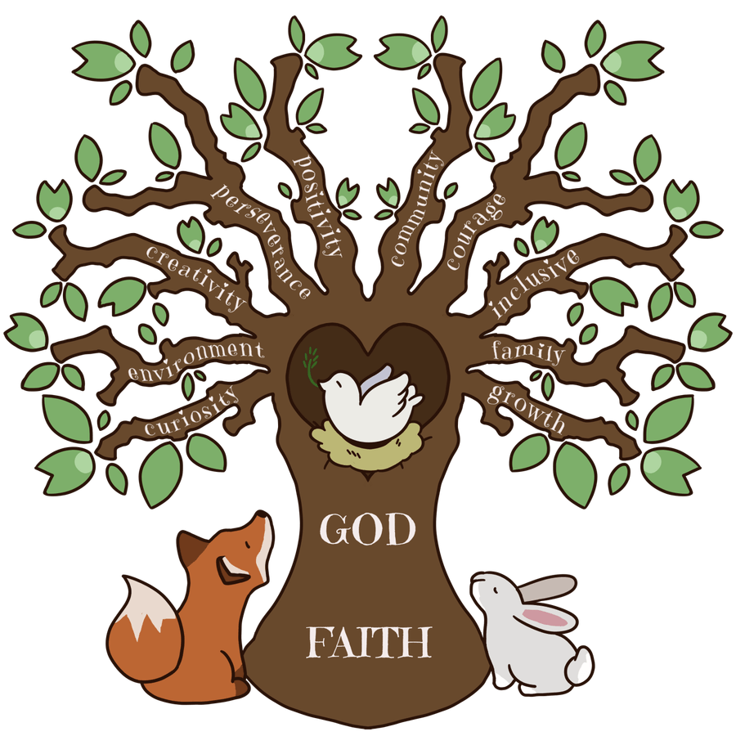

Intent

The Catholic schools of the Waveney Valley are passionate that through Art, children will be inspired to use their creativity and imagination in a holistic approach. We believe that education in the arts and our own cultural heritage, as well as that of others, provides a safe space for explorative learning so that rich development can take place.
Our aim is to work alongside the national curriculum by following the school milestones and early learning goals to provide an inspirational learning environment for all where children are challenged and celebrated in the arts they participate in. As a silver awarded Artsmark school we have worked hard collectively to raise the profile of the arts and to ensure children have opportunities to explore all what the creative arts subjects encompass to ensure our children have a life-long love of learning and enjoyment of the arts.
To ensure the children have the opportunity to be innovative to inspire future careers and create long lasting memories. We will encourage the principles of ART in a cross curricular approach using our tailored curriculums for each year group. Differentiated tasks and resources will be provided to ensure each child can progress these vital skills. We set out to enable our children to aspire and attain higher standards in learning and provide a variety of platforms for our children to shine. Being an Artsmark school has enabled us the opportunity to develop specific talents, encourage creativity and freedom of expression.

Implementation

Children at CPSWV access Art using the National Curriculum, supported through planning on KAPOW.
There are four strands running through the curriculum:
Making skills
Formal elements
Knowledge of artists
Evaluating

These strands are visited and revisited in every unit. Art and design skills
Each class has a curriculum which is inclusive of the arts and the imperative skills that need to be taught. Due to the nature of the curriculum Art will be taught in a cross curricular approach throughout the year. Each year the group develops practical skills from the milestones provided. Children will have the opportunity to be individual and expressive.
Children will be taught the skills and language relating to varying techniques explored. Opportunities to take inspiration from Art through history will be woven through subjects to ensure children are developing an understanding of its impact.
Opportunities will be provided for children to experience art in varying contexts.

Impact

The children’s learning will be measured in a variety of ways, these include:
- Self reflection on the process used.
- Questionnaires for both teachers and children.
- Evaluations of lessons/ topics taught.
- Topic book looks.
- Displays
- Exhibitions
- presentations
- Celebration events – Christmas fair etc.
Our outcomes will focus on:
- Opportunities for creativity.
- Opportunities for individuality
- Participation and motivation in learning.
- Evaluations of work
- Understanding of the skills developed and used.

