CPSWV RE Statement

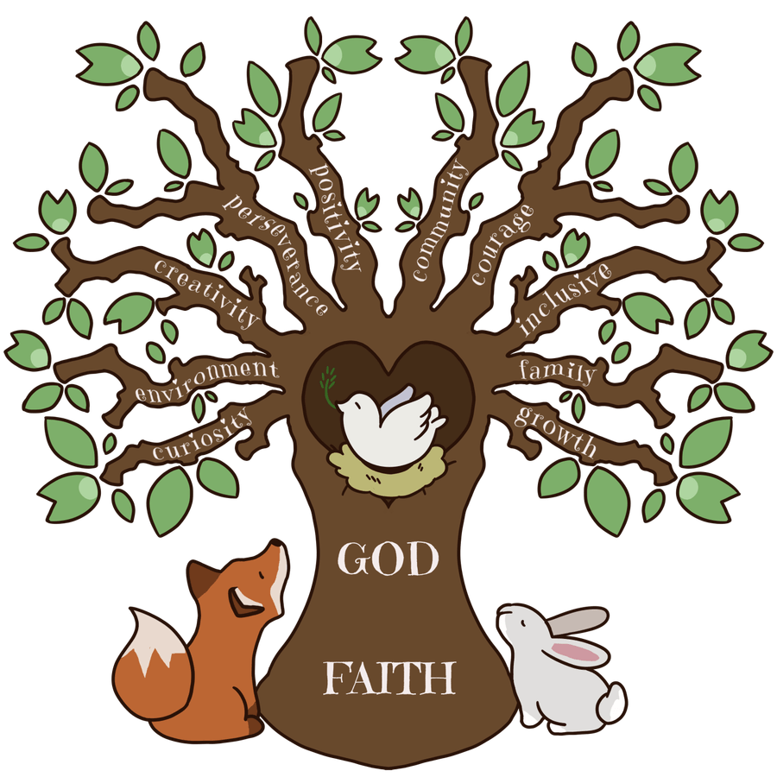

Intent

Through the teaching of Religious Education, we intend to make a distinctive contribution to the school curriculum by developing pupils' knowledge and understanding of religion, religious beliefs, practices, language and traditions and their influence on individuals, communities, societies and cultures. We aim to promote knowledge and understanding of Catholic faith and life.
Religious Education aims to enable pupils to consider and respond to a range of important questions related to their own spiritual development, the development of values and attitudes and fundamental questions concerning the meaning and purpose of life.
Religious Education is an essential component of a broad and balanced education.
Religious Education is concerned with the deep meaning that individuals and groups make of their experiences and how this helps them give purpose to their lives. It aims to engender in the children a curiosity in the ultimate questions about human life, its origin and purpose and to develop the skills required to engage in the examination of and reflection upon religious belief and practice.

Implementation

In line with Bishops’ Conference recommendations, 10% of curriculum time is allocated to Religious Education. Religious Education is taught as explicit lessons but is also embedded in other areas of the curriculum and day-to-day life of the school.
To fulfil this, ‘The Way, the Truth and the Life’ and ‘Come and See’ programmes of work are used in conjunction with the Diocesan ‘I Can Statements’ throughout the school.
EYFS - R.E is taught in topics and in blocks supported by the Diocesan ‘I Can Statements’.
KS1 - R.E is taught in topics as per the ‘Diocesan of East Anglia R.E. Curriculum Plan for Primary Schools’ supported by the ‘Diocesan I Can Statements’. Learning is done in termly topics. R.E.is taught for 2 hours and 15 minutes each week.
KS2 - R.E is taught in topics as per the ‘Diocesan of East Anglia R.E. Curriculum Plan for Primary Schools’ supported by the ‘Diocesan I Can Statements’. Learning is done in termly topics. R.E is taught for 2 hours and 30 minutes each week.
Talk for learning is a crucial component in R.E. lessons. Teachers to develop children’s thinking, spiritual responses and understanding use higher-level questions. These are collated in our class ‘Big Thinking’ Books.
Teachers undertake a programme of induction upon commencing work at our schools to develop their understanding of the Catholic ethos and teaching. This includes a ‘New to Teaching in Catholic Schools’ guide book.
Pupils will participate in Mass, feast days, Holy days collective worship which will involve religious actions and worship including the celebration of the sacraments.
The use of visits and visitors in school will enhance the RE curriculum.
Assessment, Monitoring, Recording and Reporting
Assessment of standards is carried out according to Diocesan guidelines using the criteria in the ‘I Can Statements’ agreed by the Bishops’ Conference.
Assessment tasks, classroom conferences and creative output for each module support teachers in making accurate assessments. These tasks also ensure consistency of levelling across the school. All children are assessed in all six modules over the year.
Monitoring of teaching and learning, a book scrutiny with pupils and a shared planning times with the RE Lead are done termly.
Progress and achievement in Religious Education is reported to parents/carers in a written report at the end of each academic year.
Teachers work hard to ensure there is a good balance between creativity and written outcomes in the teaching and learning of RE across the school. We strive to produce beautiful work and encourage the use of Double Page spreads to allow children to respond in their own way.
RE is not to be marked as a piece of Literacy: key words may be highlighted; the main focus should be on pupil engagement and response to the key learning objectives. We use ‘driver words’ to support children’s deeper responses. Teachers should pose challenging questions to extend pupil’s thinking and probe greater understanding.
Formal teacher assessment is carried out termly and in line with The Education Commission guidelines. Children’s knowledge and understanding is levelled as being ‘on the way to meeting’, ‘met’, ‘greater depth’ in RE on the class tracker sheet which is to is held in a shared Google Folder. These are shared with the RE coordinators and SLT.
Assessment happens all the time and is integrated into teaching and learning with strong emphasis on retrieval practices, questioning and feedback.
Multi-faith RE
To provide a broader approach to multi-faith teaching, the whole school will focus on a non - Christian faith each Summer Term and, to acknowledge that Jesus was a Jew, Judaism will also be studied each year in the Autumn Term.
The children will explore the history of religion, historical figures, festivals, religious ceremonies and rites of passage. This will encourage empathy and respect within a multi-faith society and ‘address the need to promote equality of opportunity and good relations between people from different racial groups’ - The Commission For Racial Equality, Guide for schools
Classroom Environment
Each class should have a prominent area of the classroom where RE is clearly identifiable. The display should show the current term’s RE topic’s key words and multi-faith religion or themes of the liturgical year.
There must be an accessible area for individual reflection containing a candle and prayer box. In each classroom there should be:
TWTL children’s text books (appropriate to the age of the class), God’s Story, Bibles (including Children’s bibles, Graphic Bible) age appropriate story books, cloths in liturgical colours (green, purple, red, white). Keywords for the current RE topic should be visible.
A focal area for prayer containing items to stimulate quiet reflection eg Candle, rosary beads in Oct/May, handheld crucifix, class prayer book/box
A worry box may be placed in another part of the classroom but could be part of the prayer space. The Role of the RE Coordinator
∙ To oversee and develop the RE policy within the school and review it every year ∙ To oversee the teaching and learning of RE across the school: conduct learning walks, oversee assessment of RE, working with the SLT to monitor RE work through regular sampling of work, observing displays, collating pupil voice and lessons.
∙ To lead and organise INSET in RE and worship once a term
∙ Organise whole school liturgies and liaise with the Parish Priests.
∙ To lead and support staff through good practice and team teaching.
∙ To be responsible for resources.
∙ To keep informed of new ideas and changes in the RE curriculum with the School Development Plan and to attend coordinator meetings at the Diocese.
∙ Meet and share good practice with other RE Leads in the Trust.

Impact

Religious Education at CSWV develops pupils’:-
∙ Knowledge and understanding of the Catholic faith and life;
∙ Knowledge and understanding of, and their ability to respond to, Christianity, other principal world religions, other religious traditions and world views;
∙ Understanding and respect for different religions, beliefs, values and traditions (including ethical life stances), through exploring issues within and between faiths;
∙ Understanding of the influence of faith and belief on individuals, societies, communities and cultures;
∙ Skills of enquiry and response through the use of religious vocabulary, questioning and empathy;
∙ Skills of reflection, expression, application, analysis and evaluation of beliefs, values and practices, and the communication of personal responses to these.
∙ Visits within RE have enriched the lives of the children and they are able to discuss how the experience influenced their knowledge and understanding.
Religious Education at CPSWV encourages pupils to:-
∙ Be happy learners within RE. They experience a wide-ranging number of learning challenges in RE and know appropriate responses to them.
∙ Consider challenging questions of the meaning and purpose of life; beliefs about God, the self and the nature of reality, issues of right and wrong and what it means to be human;
∙ Understand the influence of religion on individuals, families, communities and cultures; ∙ Learn from different religions, beliefs, values and traditions while exploring questions of meaning and their own beliefs;
∙ Learn about religious and ethical teaching, enabling them to make reasoned and informed responses to religious, moral and social issues;
∙ Develop their sense of identity and belonging, preparing them for life as citizens in a plural, global society;
∙ Develop respect for and sensitivity to others, in particular those whose faiths and beliefs are different from their own.
∙ Understand the Catholic Gospel Values, which will be focussed on each half term, and how these relate to their personal life and to British Values.
∙ Develop their relationship with God and become religiously literate.
∙ To be confident, resilient and actively engaged in the wider society and be stewards of God’s creation.
∙
Religious Education at CPSWV enhances pupils’:-
∙ Awareness and understanding of religions and beliefs, teachings, practices and forms of expression;
∙ Ability to reflect on, consider, analyse, interpret and evaluate issues of truth, belief, faith and ethics and to communicate their responses.
∙ Through RE, children deepen their appreciation of their faith and fulfil their God-given talents
∙ Opportunities to develop personal reflection and spirituality.
∙ Of all abilities and backgrounds achieve well in RE, reflected in outstanding progress that reveals a clear learning journey.
∙ Children to talk enthusiastically about their learning in RE and are eager to further their learning in the next stages of their education.
∙ To grow to know and love God, develop their moral and spiritual nature and deepen their faith.
∙ Live their faith in an active and positive way, always aware of the presence and love of Christ guiding them.
∙ Faith that plays a central role in the lives of the children and the decisions they make. ∙ Through wider reading in RE, to know about a wide variety of Saints, how we can learn from their example, and historical religious events and figures. They will be able to make links between Jesus’ life and teaching and link it to their own lives, making links between different forms of Christian action, such as in rituals and charitable acts.

