CPSWV RSHE Statement

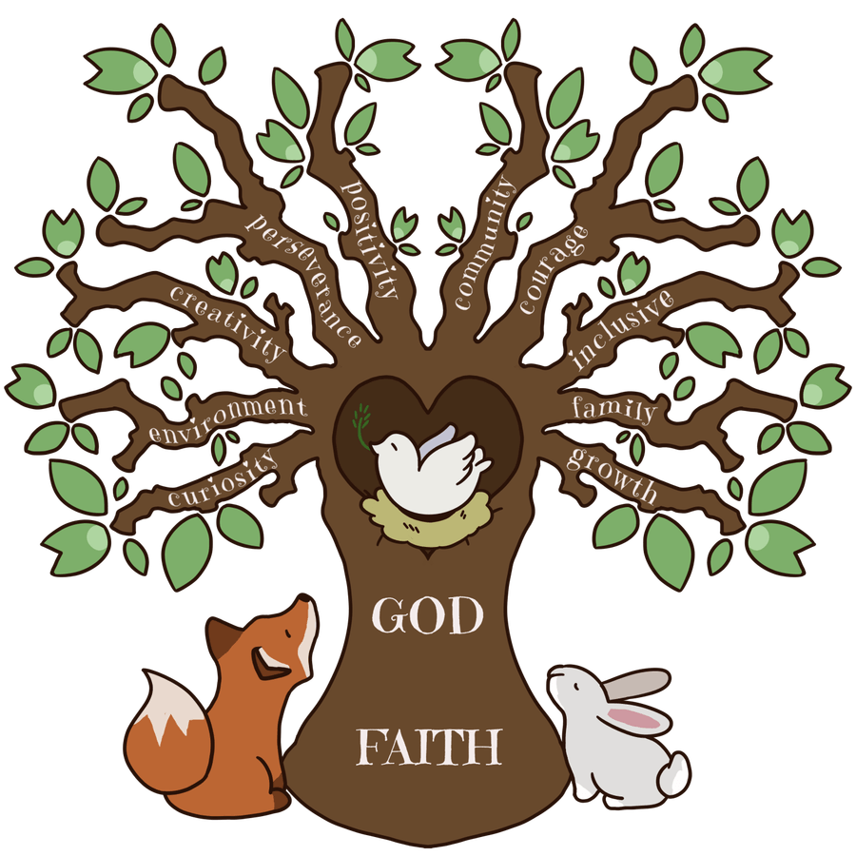

Intent

Relationship and Sex Education forms part of the mission of Catholic schools to educate the whole person. It is carried out as part of holistic education which seeks to form, as well as inform, young people in preparation for adult life.

RSHE is firmly embedded in the PSHE framework as it is concerned with nurturing human wholeness and is integral to the physical, spiritual, emotional, moral, social and intellectual development of pupils. It is centred on Christ’s vision of being human as good news and is positive and prudent, showing the potential for development, while enabling the dangers and risks involved to be understood and appreciated.

All RSHE at CPSWV is in accordance with the Church’s moral teaching. It emphasises the central importance of marriage and the family whilst acknowledging that all pupils have a fundamental right to have their life respected, whatever household they come from. It also prepares pupils for life in modern Britain.

CPSWV recognise that parents are the primary educators of their children, especially when it comes to sensitive topics such as RSHE. Therefore, we collaborate closely with parents to ensure RSHE is delivered in an appropriate way.

Implementation

At CPSWV we use Life to the Full, which is a broad programme, approved by the Diocese of East Anglia, that goes beyond Relationships and Sex Education, enabling us to also meet the government statutory requirements of Relationships and Health Education. Life to the Full enshrines Catholic values relating to the importance of stable relationships, marriage and family life. It also promotes those virtues which are essential in responding to God’s call to love others with a respect for their dignity and the dignity of the human body.

With the exception of EYFS, Life to the Full is taught using a spiral approach, with the content being repeated over a two-year cycle. This suits our mixed age-group classes and has the benefit of children revisiting topics a year on, allowing them to engage with the content in a more mature way, as well as building on prior learning and doing extension work, where appropriate. This approach continues throughout the programme and pupils revisit and build on familiar topics at age-appropriate stages, so that their knowledge and understanding grow over time.

The entire teaching of Life to the Full is underpinned by a religious understanding that we are unique children of God – created and loved by Him -and is fully inclusive of all pupils and their families.

Impact

Assessment is carried out by teacher observations together with assessment activities at the beginning and end of each unit.

By the end of the Life to the Full programme, children will have had the opportunity to develop the following attitudes and virtues:

• reverence for the gift of humanity;
• respect for the dignity of every human being – in their own person and in the person of others;
• joy in the goodness of the created world;
• responsibility for their own actions and a recognition of the impact of these on others;
• celebrating the gift of love;
• recognising the importance of marriage and family life.

By the end of the Life to the Full programme, children will have had the opportunity to develop the following personal and social skills:

• making sound judgements and good choices which have integrity, and which are respectful of the individual’s commitments;
• loving and being loved, and the ability to form friendships and loving, stable relationships free from exploitation, abuse and bullying;
• managing emotions within relationships, and when relationships break down, with confidence, sensitivity and dignity;
• managing conflict positively, recognising the value of difference;
• cultivating humility, mercy and compassion, learning to forgive and be forgiven;
• developing self-esteem and confidence, demonstrating self-respect and empathy for others;
• building resilience and the ability to resist unwanted pressures, recognising the influence and impact of the media, internet and peer groups and so developing the ability to assess pressures and respond appropriately;
• being patient and learning how to develop relationships;
• assessing risks and managing behaviours in order to minimise the risk to health and personal integrity.

By the end of the Life to the Full programme, children will have had the opportunity to know and understand:

• the Church’s teaching on relationships;
• the Church’s teaching on marriage and the importance of marriage and family life;
• the centrality and importance of virtue in guiding human living and loving;
• the physical and psychological changes that accompany puberty;
• the facts about human reproduction.

