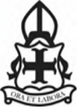

Catholic Primary Schools of Waveney Valley

History – Y 5/6 – Study of Baghdad

Timeline
570 CE  Prophet Muhammad is born. | 762 CE  The Round City of Baghdad was founded by Caliph Al-Mansur. |  | 780 CE  Muhammad ibn Musa al-Khwarizmi, the father of algebra, is born. | 830 CE  The House of Wisdom is constructed in Baghdad. | 936 CE  Abu al-Qasim al-Zahrawi al-Ansari, the father of modern surgery, was born. | 965 CE  Ibn al-Haytham, the father of optics, was born. | 1012 CE  Ibn Sina completes the book ‘The Canon of Medicine’. | 1258 CE  Baghdad was destroyed by Mongol invaders.
Key Vocabulary |  |  |  |  | Image
Baghdad | The capital city of Iraq. |  |  |  | 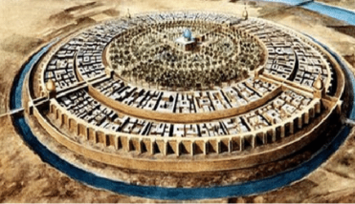  The Round City
The Silk Route | A series of ancient trade networks that connected China and the Far East with countries in Europe and the Middle East.
Islam | The religion of Muslims, which teaches there is only one God and Muhammad is His prophet.
caliph | The chief Muslim ruler, regarded as the successor of Muhammad.
settlement | A place where people establish a community.
mosque | A Muslim place of worship.
Mongol | A native or inhabitant of Mongolia. |  |  |  | Icons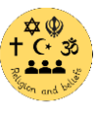 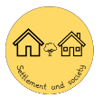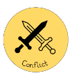
River Tigris | A river flowing from Turkey and through Iraq.
scholar | Someone who is intelligent or good at learning by studying.
hierarchy |  | A system in which members of a society are ranked.

