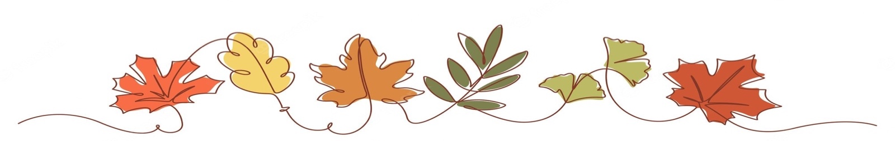
Rowan Autumn Newsletter

Welcome to Rowan! Welcome back to another year at St Benet’s. Below is an overview of our class schedule, homework and what we are coving this term. If you have any questions, please do not hesitate to contact me via the office.
Best wishes,
Miss Lewis.
Weekly Schedule
PE | Tuesday and Friday | We will be having our PE lessons every Tuesday and Friday. Children can wear their PE kits on this day to school and as it gets colder, they can wear their school hoodies.
Book Day | Wednesday | Children will bring home a reading book and reading record as part of their homework. Please could they bring in both of these every Wednesday even if their book does not need changing.
Clarinet | Thursday | Children in Year 3 and 4 have clarinet lessons every Thursday. Clarinets need to be brought into school for this session.

Homework
Reading   | To make good progress it is important that children read regularly with an adult. Children will be assigned a book at their reading level which they can read more than once to help them read clearly and to add understanding of new vocabulary. Please make a note of any reading in their reading record. Reading other books of their choice as well is greatly encouraged. If children can get house points for every time they read!
Times tables   | Learning their times tables helps children with many areas of Mathematics. Therefore, we encourage Rowan to practise their times tables for 5-10 minutes as often as possible.  At the end of Year 4 children are required to take part in the National Times table check. This is taken on a computer and involves getting used to answering 25 questions quickly. Therefore, to get used to this each child will be practising their times tables every day.  More information about the test will be available for parents in March.
What we are learning this term.

English | We will be doing a lot of reading this year and working on our reading skills this term. Our first book this year will be ‘Arthur and The Golden Rope’ and then we will be reading poetry using the collection ‘Where Zebras Go’. We will be focusing of describing settings and character description.
Maths | In Mathematics, we will be making sure our knowledge of place value is secure before moving on to be able to add, subtract multiply and divide effectively.
Science | As part of our spiral curriculum, we will be breaking our science topics into three-week blocks and returning to each topic throughout the year. We will be learning about the teeth of humans and other animals and the states of matter. Please look on our class webpage to find our knowledge organisers.
Religious Education | This term we will be learning about the importance of God’s promise to Abraham. We will then learn about the importance of faith through prayer as a way to show hope and love to others.
PE | In PE this term we will be working on our personal development. We will be improving our footwork and balance skills.
History | We will be investigating what life was like in prehistoric Britain to discover the changes that occurred between the stone age to the iron age.
Art | We are learning so much in art this term. We will be developing our sketching and shading skills to create drawings which show dimension and perspective. We will then move on to plan and create a mixed media drawing which will turn into a print.
Spelling | We will be continuing to practise spellings in school with investigations and short spelling games.
Clarinet lessons
In music we will be working on our performance skills. The children will be having clarinet lessons each week and will build their confidence in playing the instrument. Clarinets will come home after a few weeks for children to practice with and must be returned to school every Thursday.
First Holy Communion

If your child is in year 3 or 4 and would like to make their First Holy Communion next year, preparation classes will hopefully begin in October. When our new parish Priest Cannon Simon joins us, we will have more information on when classes will be soon. A letter from the parish will follow with this information. If you would like to register your child’s interest, you can send an email to our new priest at simon.blakesley@rcdea.org.uk

