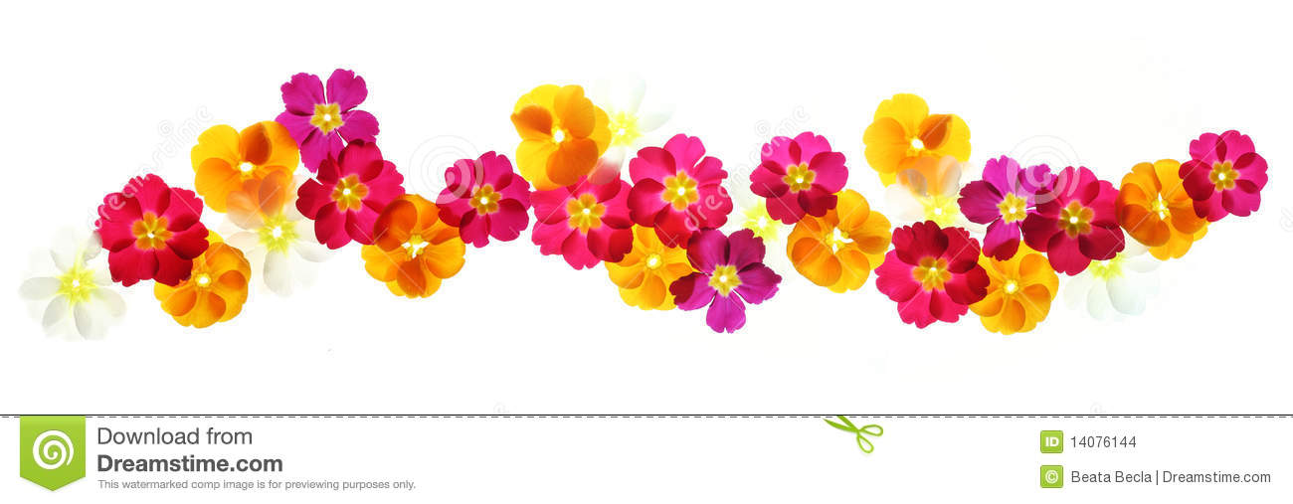
Rowan Spring Newsletter

Happy New Year.
Please find a reminder of some key information in this newsletter including our weekly activities, homework and what we are learning.
Weekly Schedule
PE | Tuesday and Friday | We will be having our PE lessons every Tuesday and Fridays. Children can wear their PE kits on this day to school and as it gets colder, they can wear their school hoodies.
Book Day | Wednesday | Children will bring home a reading book and reading record as part of their homework. Please could they bring in both of these every Wednesday even if their book does not need changing.
Clarinet | Thursday | Clarinet lesson is every Thursday morning. Please can children bring their clarinet every week for their music lesson.

Homework
Reading   | To make good progress it is important that children read regularly with an adult. Children will be assigned a book at their reading level which they can read more than once to help them read clearly and to add understanding of new vocabulary. Please make a note of any reading in their reading record. Reading other books of their choice as well is this is greatly encouraged.
Times tables   | Learning their times tables helps children with many areas of Mathematics. Therefore, we encourage class 3 to practise their times tables for 5-10 minutes daily.  At the end of Year 4 children are required to take part in the National Times table check. This is taken on a computer and involves getting used to answering 25 questions quickly. Therefore, to get used to this each child in Year 4 will have a times table check account from September to use to practise their times tables.  More information about the test will be available for parents will in March.

What we are learning this term.
English | Our first story has sparked everyone’s imagination as we learn about traditional storytelling from central Asia. We have been talking about the book ‘Tales told in Tents’ and will be practising our storytelling skills We will then be looking at the traditional tale ‘Firebird’ and writing our own letters.
Maths | In Mathematics, we are continuing practising our methods of multiplying and dividing larger numbers. We will then be looking at the place value of decimal numbers and fractions before half term. After this we will be looking at solving problems involving shapes and statistics
Science | As part of our spiral curriculum, we will be breaking our science topics into three-week blocks and returning to each topic throughout the year. We will be looking at how animals are classified and then moving on to learning all about sounds.  The children will be focusing on learning about the digestive system which builds on their knowledge about teeth.
Religious Education | This term we will be learning about what Jesus taught his follower on earth, the miracles he performed and reflecting on what Jesus’s teaching mean for our life today. We will be focusing on the Catholic social teaching of Solidarity and how we can help those in need like Jesus did.
PE | In PE this term, we will be working on our cognitive development. We will also be enjoying taking part in gymnastic lessons. Please make sure children have a PE hoodie when it is colder.
Geography | Our geography topic this term is focusing on The United Kingdom and comparing the place that we live into other places in the UK. After half term, we will then be using maps and atlases to compare the UK to Italy and studying volcanoes and earthquakes.
Art and DT | In art, we will create a final painting that shows an understanding of how colour can be used to show light and dark, and therefore show three dimensions. After half term, we will be designing a pavilion that is strong, stable and aesthetically pleasing. The children will then select appropriate materials and construction techniques to create a stable, free-standing frame structure.

