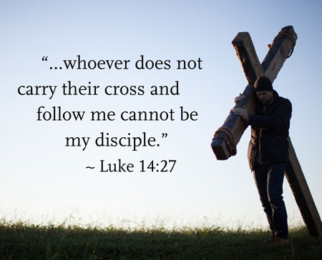
FOUNDATION OF LOVE!
We have had another great week in school and the children have enjoyed showing me their amazing work and impressing their teachers with their attitude to learning. Our assemblies and prayers this week have reminded us of something very important: God’s dream for each of us is to know Him, to love Him and to share His love with others. This is what we are made for and it is what helps us to live life to the full.

At the start of term, it feels like the perfect moment for a fresh beginning. Just as the Book of Wisdom reminds us, we are never alone—God is with us to guide us on our journey. This week, our children have been praying for the Holy Spirit to help them: to look back with thankfulness, to be present with gratitude, and to look forward with hope and excitement for all that is to come. These are all important skills in shaping them into confident, positive individuals.

As we move into next week, a reminder that we will be coming together as a school community next Thursday, 18th September at 11am to celebrate Mass together. All are welcome to join us in church for this.
NEW RECEPTION STARTERS 2026
The application process has already opened for those wanting their children to start school in September 2026. If your child turns 4 between 1st September 2025 and 31st August 2026, you need to apply for a place for your child. The window is open until 15th January 2026.

We will be holding an Open Day on Monday 6th October where parents are able to turn up to the school and have a tour with Mr Kennedy. Tours will be made available throughout the day. However, we understand that working parents can’t always make that day. Therefore, we encourage those applying for a place next year to contact school and make an appointment to have a look round at a convenient time for them. If you have a family member or friend who is going to be applying for a place next year, please share this information with them!
FACEBOOK PAGE
Our school Facebook page will be utilised to share some of the amazing things we get up to in school. Please make sure you have followed our school page to get all the latest information about what we have been up to as well as our upcoming events. If possible, please share some of our posts so that as many people as possible see the amazing things happening at St. Benet’s. If you are not sure where to find our school page, please click this link:
https://www.facebook.com/stbenetscatholicprimaryschool/
YEAR 6 SECONDARY SCHOOL APPLICATIONS LETTER
Our Year 6 parents should have received a letter this week detailing the arrangements for applying for a place at high school. If you haven’t received a copy of this email, please contact the school office and a paper copy will be sent home. A reminder that the deadline for applying for a secondary school place is Friday 31st October 2025.

MARCELINO – FAMILY’S NORFOLK HIKE OF HOPE FOR CHARITY!

One of our Y4 students, Marcelino, will be taking part in a family organised ‘Hike of Hope’ from 19 – 21 September. The group of 13 will cover 38 miles from the Cathedral of St. John the Baptist in Norwich to the Shrine of our Lady in Walsingham. They are taking part in this walk to raise funds for Aid to the Church who support displaced children affected by war, violence and natural disasters. Last year, they raised £4000 climbing Ben Nevis.

If you would like to support Marcelino and his family, you can donate by clicking on this link to the right. Thank you for your support.
CLASS NEWSLETTERS
You should have received a copy of your child’s class newsletter today. This details lots of important information about your child’s Curriculum, Homework Expectations, PE, Forest School and other useful information. Please make sure you look out for this and speak to your child’s class teacher should you have any questions.
PTA AGM
You are warmly invited to attend the PTA Annual General Meeting (AGM) on Wednesday 1st October, 9.00am in our school library at St Benet’s Primary School.

The aims of our PTA are simple but important. We are here to advance the education of pupils in the school, in particular by:
- Developing effective relationships between staff, parents, and others associated with the school.
- Engaging in activities or providing facilities or equipment which support the school and enrich the education of the pupils.

Over the years, the PTA has helped to strengthen our school community and provide resources and experiences that directly benefit all children.

The PTA is a vital part of our school community — but its future depends on the support of parents and carers. The commitment required is minimal, and every contribution makes a difference. Whether you are interested in becoming a trustee, offering occasional help, or simply finding out more, your involvement matters. Even if you’re not able to commit to being a PTA member, we would still love you to join us at this meeting, where we’ll share what the PTA has achieved over the past year and our plans for the year ahead.

Please join us on Wednesday 1st October to ensure the PTA can continue its work for the benefit of all pupils.

With thanks and best wishes, The PTA
DATES FOR YOUR DIARY
SEPTEMBER
Thursday 18th – 11am – Whole School Mass in St. Benet’s Church

OCTOBER
Wednesday 1st– All Day – Whole School Photographs and PTA AGM – 9am
Thursday 2nd– 9:30am – 3:00pm – Year 6 Art Day at Sir John Leman High School
Thursday 23rd – 3:15pm – School Closes for Half-Term

NOVEMBER
Monday 3rd – 8:45am – School Opens

