CPSWV English Statement

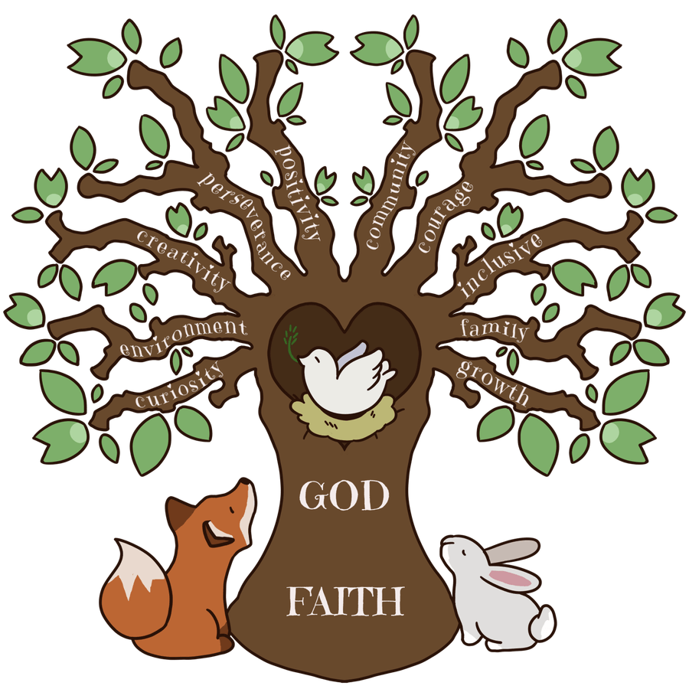

Intent

At CPSWV, we believe that English and communication are key life skills. Through the English curriculum, we will help children develop the skills and knowledge that will enable them to communicate effectively and creatively through spoken and written language and equip them with the skills to become lifelong learners.
English is at the heart of all children’s learning. It enables children both to communicate with others effectively for a variety of purposes and to examine their own and others’ experiences, feelings and ideas, giving these order and meaning.
We believe that reading is a life skill that every child should be entitled to have. Without the ability to read and decode text, so much is closed off to a child and later as an adult. We want to inspire children through books as well as to promote a love of reading; empowering our children to become lifelong readers. Books should not be seen as a chore but as a gateway to other worlds, the opening of our imaginations.
English is central to children’s intellectual, emotional and social development; it has an essential role across the curriculum and helps pupils’ learning to be coherent and progressive. Our schools’ values can be seen throughout the subject where we use texts to reinforce curiosity, environment, creativity, perseverance, positivity, community, courage, inclusivity, family, growth and faith.

Implementation

All the children in our schools will have access to daily English lessons. In Reception and KS1, there will be daily phonics sessions and where needed, this will continue into KS2. Curiosity in spelling will be encouraged through an investigation and practice programme that will run over a fortnight. Children will have access to quality fiction, non-fiction and poetry texts in the English session and all class teachers will promote discussion and analysis of these texts. The key to understanding the world around us is through observation and discussion. Children will be given the opportunity to explore new and unfamiliar vocabulary and class teachers will model its use and effect. Children will have opportunities to practice writing through smaller tasks but will work towards at least one extended piece per unit of work. Grammar and punctuation will be taught both in relation to the texts being studied as well as discretely.
Children will have additional opportunities to extend their knowledge and understanding of a broad selection of texts through additional reading sessions. These sessions will focus on everything from song lyrics and poetry through to play scripts and newspaper articles. Texts will be selected from across all curriculum subjects as well as the world beyond. Fluency skills, as well as comprehension, will be the focus in these sessions.
At CPSWV, we value books as a means by which to not only learn, but to enjoy ourselves. As such, each class will have at least one dedicated reading slot each day, where an adult reads aloud to a class for pure enjoyment.

Impact

All class teachers will use an array of formative assessment strategies to ascertain the learning of the children. This might be through, amongst other things, discussions, quizzes, written work, drama and presentations.
Phonics will be assessed by an adult at the end of each half term and their progress will be checked. Teachers of children in Year 1 will administer the Phonics Screening Check. Those children who do not pass will attempt this again in Year 2.
Reading and GAPS (grammar, spelling and punctuation) will be formatively assessed at the end of the autumn and summer terms. Teachers might wish to supplement this at the end of the spring term. Teachers of children in Year 2 and Year 6 will facilitate the end of key stage SATs tests in line with government guidance.
Writing will be formally assessed at the end of every unit of work. At the end of every term, class teachers in Year 1, Year 3, Year 4 and Year 5 will complete the SJBCMAT writing grids to track the progress of children. Writing moderation will take place at least twice a year across the SJBCMAT for Year 2, Year 4 and Year 6 to ensure that class teachers and their colleagues across the MAT are confident in their assessments.
CPSWV firmly believes that the teaching of the English curriculum will be inclusive to all children, inspiring them through an engaging learning experience, which will enable them to make good progress and leave us as responsible, happy citizens who are confident communicators with a love of reading and writing.

