CPSWV Geography Statement

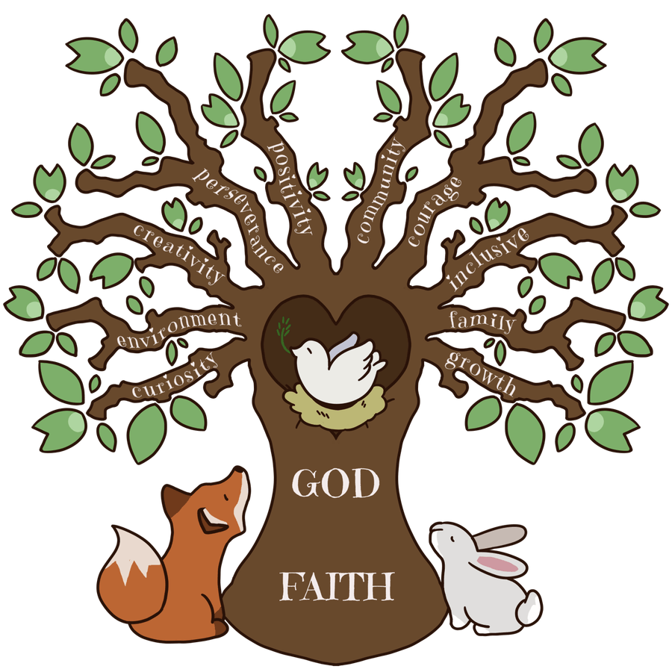

Intent

At the CPSWV our educational intent when teaching geography is that all children develop skills and understanding to enable them to be geographers. We want children to have an awareness of the diverse nature of the world, and a sense of respect for it and diversity within it. We want children to be aware of and understand the impact humans have on the world as well as physical features that are out of our control. We want children to have a secure understanding of the national curriculum required knowledge but also to be able to wonder about the wider world and think critically about current issues.

We aim to ensure children leave our school as competent geographers who understand that geography is concerned with place, space and scale.
Through each topic we aim to cover:
- Place, which gives children subject knowledge such as the names and features of a location, characteristics.
- Space, where in the world is this place we are studying and how does it connect to us, this also covers using maps to find places
- Scale, how does our view of a place change if we look from afar or on a small scale? In addition to this we want them to leave as curious minds who question what is in front of them to find out more about places.
We have divided the content so that staff and children can clearly see that some areas of the geography curriculum are UK based and some are non-UK based.

Implementation

Our geography learning is planned based on our curriculum topics which ensure coverage of the curriculum and milestones. We also ensure that skills and knowledge are revisited at regular intervals, to ensure these become embedded, for example map skills should be revisited in every geography unit to develop children’s confidence and competence and as they progress through the skill they are exposed to more complex examples which require a higher level of skill and accuracy. Teachers use a range of high quality sources to bring geography to life, including high quality texts which enables links to English lessons as well as trips and visitors. All geographical skills and knowledge are embedded in a relevant context, with as much meaning to children as possible, for example if studying volcanoes children would study a real volcano to help embed their learning. Learning objectives take account of national curriculum knowledge as well as driver words which ensure children’s skills are being developed alongside subject knowledge.

Impact

Children’s progress is measured using meaningful assessment methods which can inform teachers planning to maximise children’s learning. For example we use POP tasks, quizzes and interactive feedback at regular intervals to check where children are in terms of understanding and knowledge which then means planning can take account of misconceptions. Teachers also use knowledge organisers in starters and plenaries to check understanding. At the end of units, children produce a summary of their learning. This could be in the form of a ‘double-page spread’, a presentation, an essay or a mixture of these. Teachers use an assessment pro-forma to consider which children are working below and above expectations in order to ensure these children’s needs are considered in subsequent units. Class teachers analyse how the unit of work has worked and feed this back to the subject leader.

